Paper or plastic
A perennial gag for much of the history of movies is the down-on-his-luck character symbolically reaching rock bottom when the bottom falls out – literally – from a bag or box he is carrying. A typical scene, common to dramas and comedies alike, centers on our hapless hero attempting to complete one of the most mundane of day-to-day activities, namely buying groceries, with no success. For one reason or another, be it weight or wetness, when he attempts to lift the grocery bag, typically full of can goods and fruit, the bottom of the bag loses whatever semblances of solidity it had and every item plummets to the ground as he watches on with surprise. The actor then hangs his head in resigned defeat or rolls his eyes in disbelief and we relate. Of course, this household disaster writ small only works with paper bags and so the movie most likely was produced before the mid-1980s. After that time, as some may say, America began its “dangerous obsession” with plastic bags – an obsession that may be coming to an end as more and more people return to the “natural goodness” of paper bags after they “realize” just how bad these “little petroleum pieces-of-hell” actually are. As we explore this pendulum shift from paper to plastic and now heading back to paper, we will find a bigger lesson on economics and rational thinking.

In his engaging article History of Plastic Bags: How Did We Get Here, author David Evans walks through the timeline whereby the paper bag was supplanted by the single-use plastic bag, hereafter usually referred to as simply the plastic bag. The plastic bag comes from humble roots beginning with the invention of polyethylene in 1933. While this chemical concoction was intriguing, it lacked the necessary strength to become a household fixture. A couple of decades later, high-density polyethylene (HDPE to those in the know) is invented and, to quote Evans, “HDPE gives plastics the strength they need to be light, moldable, and still strong.” In 1965, Karl Ziegler was awarded the Noble prize in chemistry for his invention of HDPE. That same year, the plastic grocery bag was invented by the Swedish company Celloplast. A scant two years later, the famous ‘plastics’ scene from The Graduate was released for general consumption and a polymer-plague was unleashed on mankind.
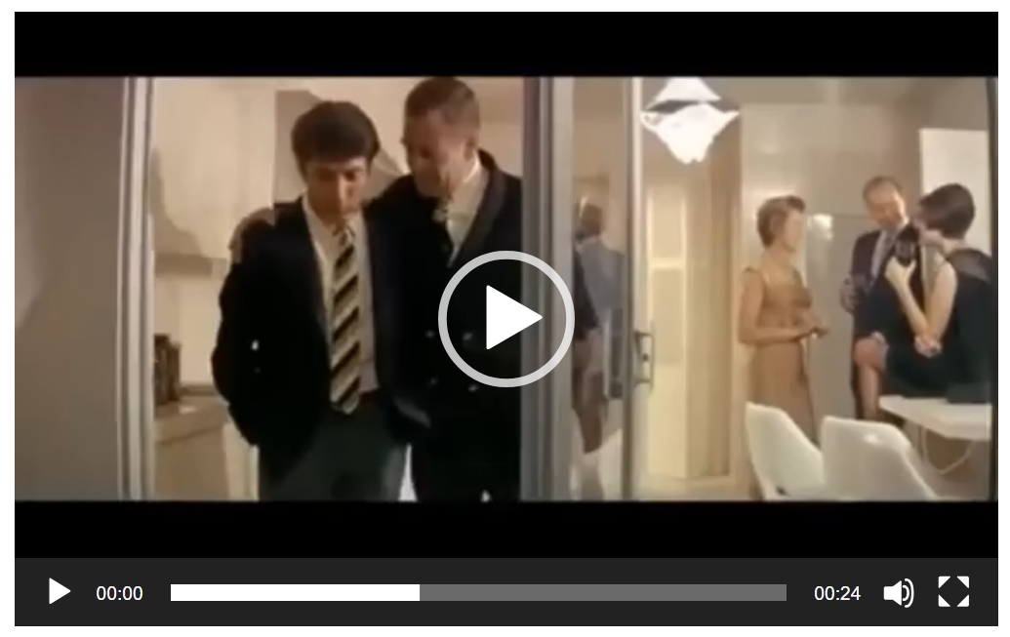

<Graduate clip>

With plastic fever gripping the country, somewhere, somehow, around the late 1970s or the early 1980s, we collectively decided that plastic bags were the way to go. As I remember it, we argued that paper bags presented a clear and existential threat to everyone everywhere, that we wanted to save the forests, and that we could protect the environment by using products that came from organic materials made from living organisms long since expired. Of course, behind the scenes, there were undoubtedly rational cost-benefit analyses being performed that showed corporations the saving that plastic bags promised given that they are generally lighter than paper bags. Assuredly, there was also lobbying being done by the plastics industry more vigorously than the paper industry. But none of this made it through to the average Joe. The slickest devices of Madison Avenue packaged the changed, which Evans describes as a “transition [that] was out of the hands of the consumer, from paper to plastic as friendly to both Mother Nature and our wallets. Deep down, I still suspect that all those movie gags had a powerful effect on our subconscious and we all bought whatever excuse spared us from being the butt of the joke.

Regardless of exactly how all these reasons blended, in 1982 Safeway and Kroger supermarket chains made the transition and plastic bags became a common sight in the checkout lane. For a while, most of us were given the choice: “paper or plastic”. But, eventually, even this choice went away. Only a few iconoclastic brands, such as Trader Joes, continued to use paper bags. As the number of people grew and the number of goods being purchase skyrocketed, it started to become clear to even the densest amongst us, that plastic bags did have a downside, beyond the fact that they are stubbornly difficult to open. Because they couldn’t biodegrade, a plastic bag that went rogue and escaped its owner’s grasp would eternally drift around streets and highways like some demented will-o-the-wisp, blowing this way or that as the wind gusted or traffic passed by. Clean up costs mounted and, despite the efforts that were made to recycle them, only a small fraction of the available bags ended up in other products; the bulk ended up in landfills. And so, with growing alarm, society is now turning its back on single-use plastic bags and again re-embracing the humble brown paper bag. New York state has already take steps to ban single use plastic bags in many venues (see e.g., New York State to ban plastic bags—here's why).

Now there is nothing wrong with changing course and learning from our mistakes. But there is a huge difference between rationally responding to challenges and emotionally responding to propaganda. Apparently, those environmentalists of the 1970s and 80s who advocated the need to eliminate paper bags never looked at the fact that trees grow naturally; that people can cultivate and grow trees for the express purpose of being harvested for lumber and paper; and that the vast majority of the energy to grow and mature new trees is freely given to us by the Sun. By the same train of thought, if one is being honest, are the advocates pushing for a migration back to paper now really looking at the whole, interconnected system or are they merely looking at the problem in front of their collective face? The bane of economic decision making is focusing on the problem that is apparent at the cost of neglecting the unseen problems that will follow in the wake of a poor decision.

Of course, only time will tell if this current spate of drama-driven decision-making approaches rationality or whether forty years from now we’ll be lamenting the demise of the plastic bag. Sadly, it seems certain, regardless of whether everything “turns out alright” or “turns out to be a disaster”, that most of us won’t get any more economic wisdom because the bottom of thinking has dropped out.

